

# **School of Computer Science and Engineering**

# **CSE4015 - Human Computer Interaction**

**Web Platform for Dynamic Recipe**

**Filtering & Sharing**

# Submitted by

# **Aleena 20BCE0200**

# Under the guidance of

# **Professor Swarnalatha P**

**Abstract**

The goal of this project is to develop a comprehensive recipe management system that enables users to efficiently explore, filter, and view detailed information about various dishes. The system is designed to provide a user-friendly interface for searching recipes based on ingredients, cuisines, diets, and other relevant filters. Additionally, users can contribute to the platform by submitting their own recipes, enhancing the diversity of available dishes. The project aims to create a seamless and enjoyable experience for both recipe seekers and contributors.

# **Introduction**

In today's fast-paced work environment, individuals are constantly engrossed in their professional responsibilities, and so, they aspire to swiftly cook their meals without dedicating much time to the decision-making process. The monotony of consuming the same dishes daily can lead to a sense of tedium, thus, there arises a need for a diverse array of accessible recipes. Yet, formulating such recipes presents a challenge of its own, such as modifying meals daily to cater to the diner's preferences while also prioritizing their nutritional needs. Moreover, oversight in stocking the kitchen with essential ingredients is another issue that can surface, which becomes particularly troublesome when individuals desire to prepare a quick meal.

In the realm of culinary exploration and meal preparation, the advent of digital technology has brought forth both challenges and opportunities. With the relentless pace of modern life, individuals seek convenient and efficient ways to access diverse recipes that cater to their culinary preferences, nutritional needs, and the ingredients readily available in their kitchens.

The existing landscape of culinary websites and platforms offers a multitude of recipes, but navigating through this vast sea of content can be a daunting and laborious task. Many existing platforms heavily rely on video content for recipe sharing. While videos provide visual guidance, they can be time-consuming and less efficient for those seeking quick access to ingredient lists and instructions. This has led to the need for a more accessible and text-based alternative, enabling users to quickly grasp information without the hassle of watching entire videos.

To address these challenges and enhance the user experience in culinary exploration, this project introduces a novel web application which serves as a centralized repository of a vast number of recipes. Its core functionality empowers users to effortlessly filter recipes based on the ingredients available at their disposal and their unique nutritional requirements. Additionally, the platform encourages user participation by enabling recipe contributions, fostering a vibrant community of culinary enthusiasts, and therefore promoting the tradition of recipe-sharing. With this innovative solution, we aim to streamline and elevate the culinary journey, offering users a more efficient, accessible, and comprehensive resource for discovering and sharing recipes, all in one centralized digital hub.

**Scope**

My web platform will cover the following key features and functionalities:

1. **Recipe Search and Filtering:**
   * Users can efficiently search for recipes based on ingredients, cuisines, diets, and other relevant filters.
   * Advanced filtering options, including ingredients, cuisine types, diet preferences, and sorting preferences.
2. **Recipe Display:**
   * Detailed information for each recipe, encompassing preparation time, servings, weight per serving, dish type, diet type, and cuisine.
   * In-depth nutritional information such as protein, fat, carbohydrates, glycemic index, glycemic load, and nutrition score.
3. **User Contribution:**
   * Users can actively contribute to the platform by submitting their own recipes.
   * Submitted recipes will undergo a review process before being added to the system to ensure quality and accuracy.
4. **User-Friendly Interface:** The system will have an intuitive and user-friendly interface for easy navigation and interaction.

**Objectives**

This HCI project endeavours to address several culinary challenges by creating a dynamic web application with the following objectives:

1. **Recipe Accessibility and Customization:** To provide users with a platform where they can effortlessly input their available ingredients and nutritional requirements, allowing the application to filter and suggest recipes that closely match their criteria.
2. **Effortless Recipe Discovery:** To simplify the process of finding diverse and tailored recipes, thereby minimizing the need to scour various websites for culinary inspiration.
3. **Community Engagement:** To foster an interactive community by enabling users to contribute their own recipes, thereby promoting the cherished tradition of sharing culinary wisdom.

**Requirement Specification**

**Hardware Requirements**

* The system should be accessible on standard personal computers and laptops.
* Minimum system requirements include a modern web browser and a stable internet connection.

**Software Requirements**

1. **Frontend:** Utilize HTML, CSS, and vanilla JavaScript for the user interface.
2. **Backend:** 
   1. Use Node.js for the server-side development.
   2. Implement Express.js framework.
   3. Use MongoDB database system for storing the recipes.
3. **Database:**
   1. Implement the NoSQL database to store recipes, and other relevant information.
   2. Ensure proper indexing and optimization for efficient data retrieval.
4. **Testing:**
   1. Conduct unit testing and integration testing for both frontend and backend components.
   2. Perform user acceptance testing to ensure the system meets user expectations.
5. **Scalability:** Design the system to be scalable to accommodate a growing database of recipes and user contributions.

**Methods Identified**

The development and implementation of the recipe web platform involve a variety of methodologies and technologies to ensure a robust and user-friendly platform. The following methods have been identified for the successful execution of the project:

1. **Agile Development Methodology:** Adopting the Agile approach allows for iterative and incremental development, ensuring flexibility to accommodate changes and enhancements throughout the project lifecycle. This methodology is particularly beneficial for a dynamic and evolving system like this.
2. **User-Centered Design (UCD):** Utilizing the principles of User-Centered Design involves engaging potential users throughout the design and development phases. This approach ensures that the system is intuitive, user-friendly, and aligned with the expectations and needs of the target audience.
3. **Full-Stack Development:** Leveraging full-stack development enables the creation of a comprehensive system by addressing both frontend and backend requirements. Technologies such as Node.js, Express.js, and MongoDB on the backend, coupled with HTML, CSS, and JavaScript on the frontend, facilitate a seamless and integrated development process.
4. **Database Management:** Implementing a robust database management system, such as MongoDB, allows for efficient storage and retrieval of recipe data. The NoSQL nature of MongoDB provides flexibility in handling diverse data types and supports scalability as the system grows.
5. **Responsive Web Design (RWD):** Prioritizing Responsive Web Design ensures that the system is accessible and user-friendly across various devices and screen sizes. This method involves designing and developing the interface to adapt seamlessly to desktops, tablets, and mobile devices.
6. **Continuous Integration and Deployment (CI/CD):** Implementing CI/CD pipelines ensures automated testing, integration, and deployment processes. This method enhances the development workflow, accelerates release cycles, and maintains the stability and reliability of the system.

**Process Model**

The recipe management system follows an iterative and incremental development process, aligning with the Agile methodology. The development lifecycle comprises the following key phases:

1. **Project Planning:**

* Define project scope, objectives, and requirements.
* Establish the development timeline and allocate responsibilities.
* Plan sprints, milestones, and release cycles.

1. **Requirements Gathering:**

* Engage stakeholders to gather detailed requirements.
* Identify user stories, features, and functionalities.
* Prioritize requirements based on business value.

1. **Design Phase:**

* Create wireframes and prototypes for the user interface.
* Define the system architecture, including frontend and backend components.
* Plan the database schema and relationships.

1. **Implementation:**

* Develop the frontend using HTML, CSS, and JavaScript.
* Implement backend logic using Node.js and Express.js.
* Integrate MongoDB for data storage and retrieval.

1. **Testing:**

* Conduct unit testing for individual components.
* Perform integration testing to ensure seamless communication.
* Execute system testing to validate end-to-end functionality.
* Implement automated testing for continuous integration.

1. **User Acceptance Testing (UAT):**

* Collaborate with end-users to validate system functionality.
* Gather feedback on usability, performance, and features.
* Iterate on design and functionality based on UAT results.

1. **Deployment:**

* Package the application for deployment.
* Implement CI/CD pipelines for automated deployment.
* Deploy the system to a production environment.

1. **Monitoring and Optimization:**

* Implement monitoring tools to track system performance.
* Gather analytics on user interactions and preferences.
* Optimize the system based on real-world usage.

1. **Maintenance and Updates:**

* Address bug fixes and issues promptly.
* Release updates and new features based on user feedback.
* Continuously refine and enhance the system.

# **System Architecture – Block Diagram** The system architecture of the recipe management system can be represented through a block diagram, illustrating the key components and their interactions:

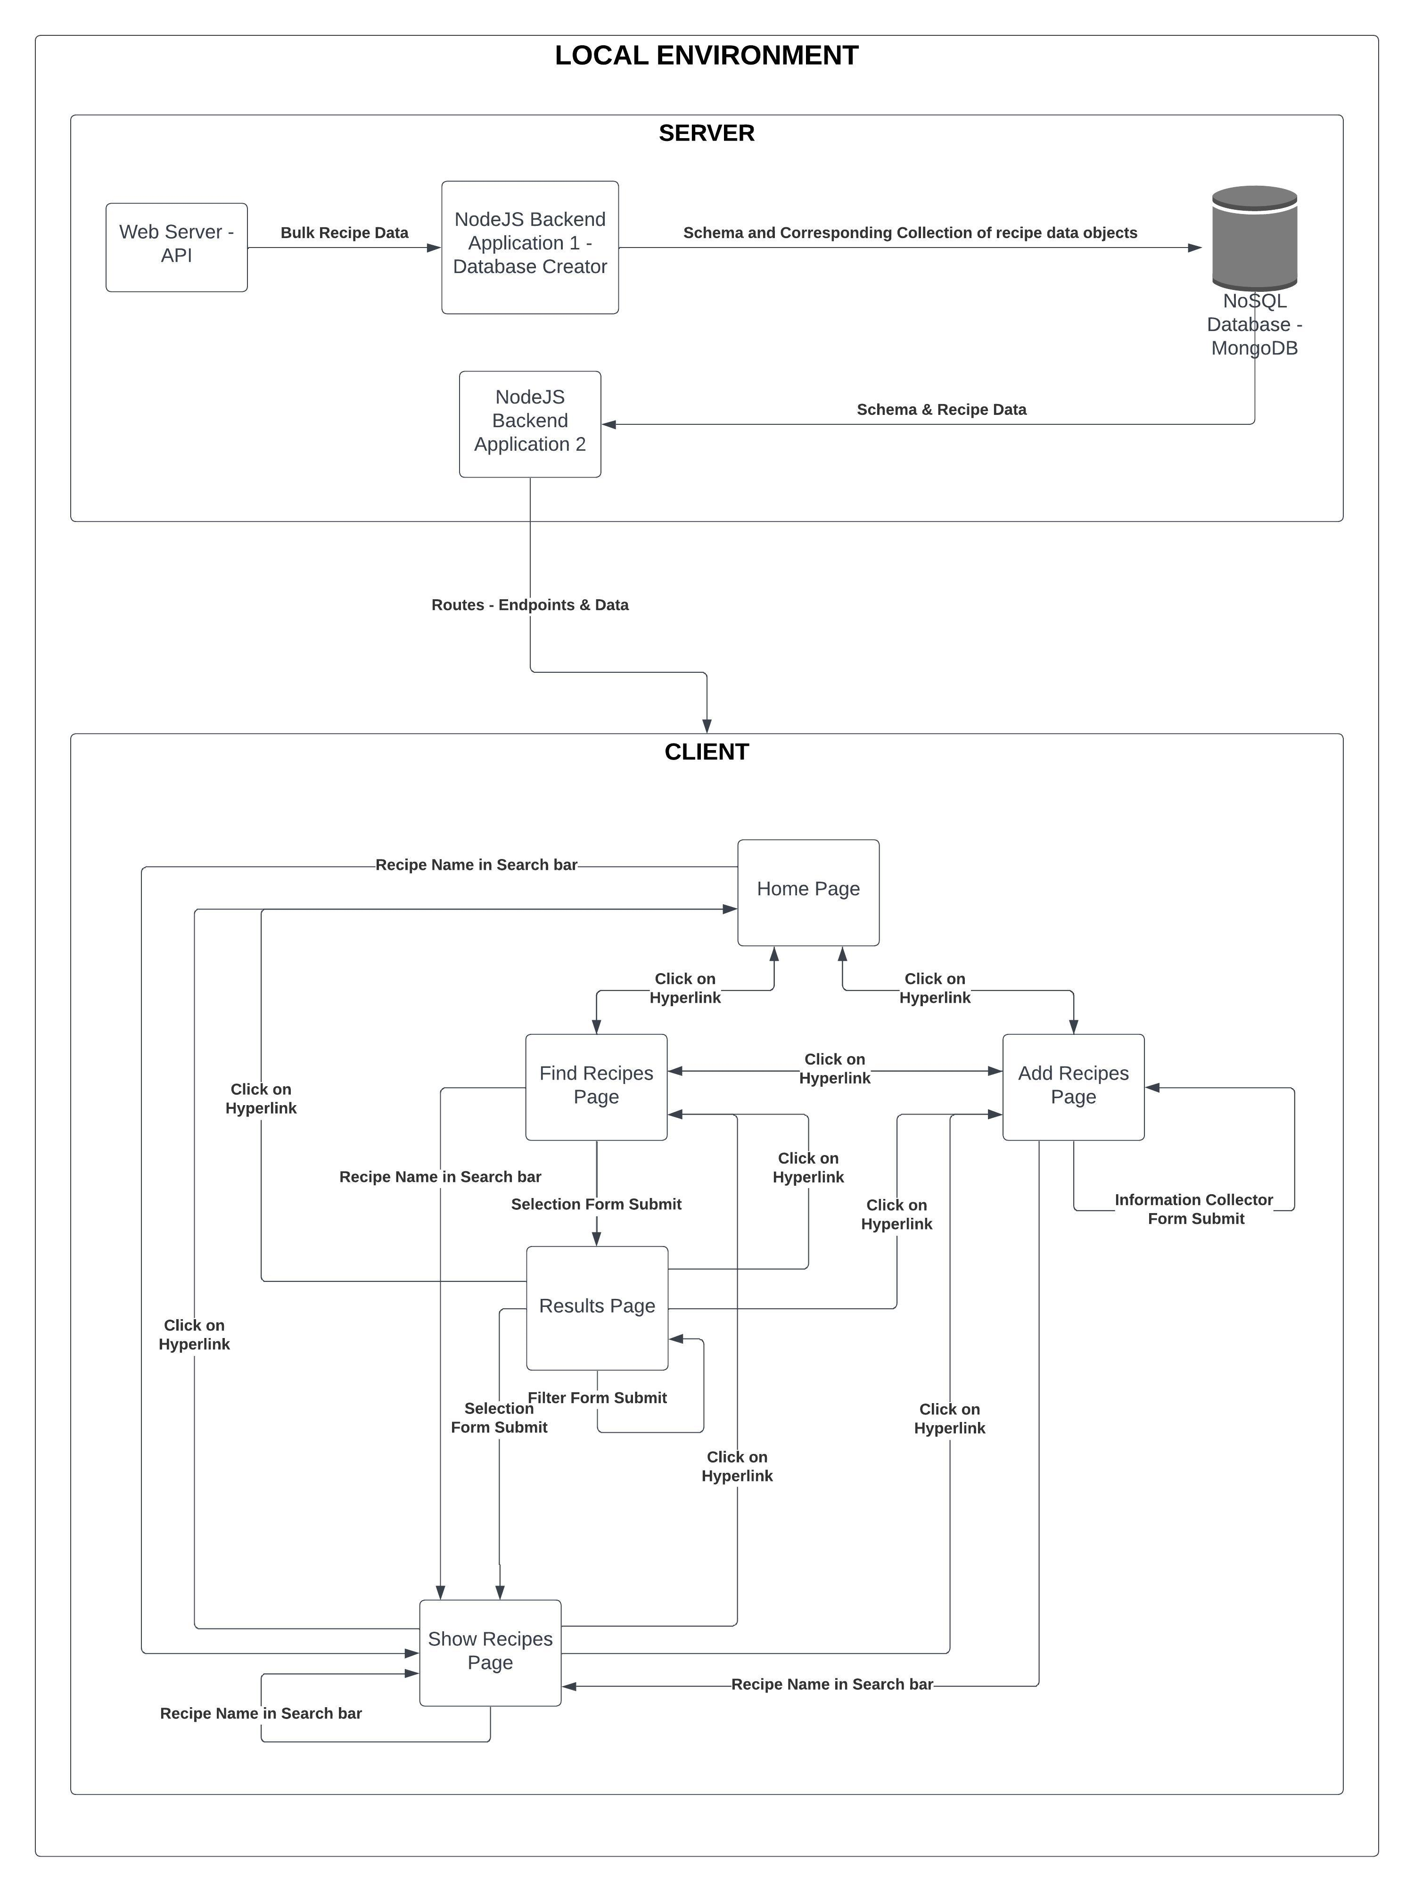

Figure 1: Block Diagram of the System showing the dataflow and interactions between components

**Design Specifications**

**HTA**

Hierarchical Task Analysis is a method used to describe the structure of tasks and subtasks within a system. It breaks down complex tasks into a hierarchy of smaller, more manageable elements.

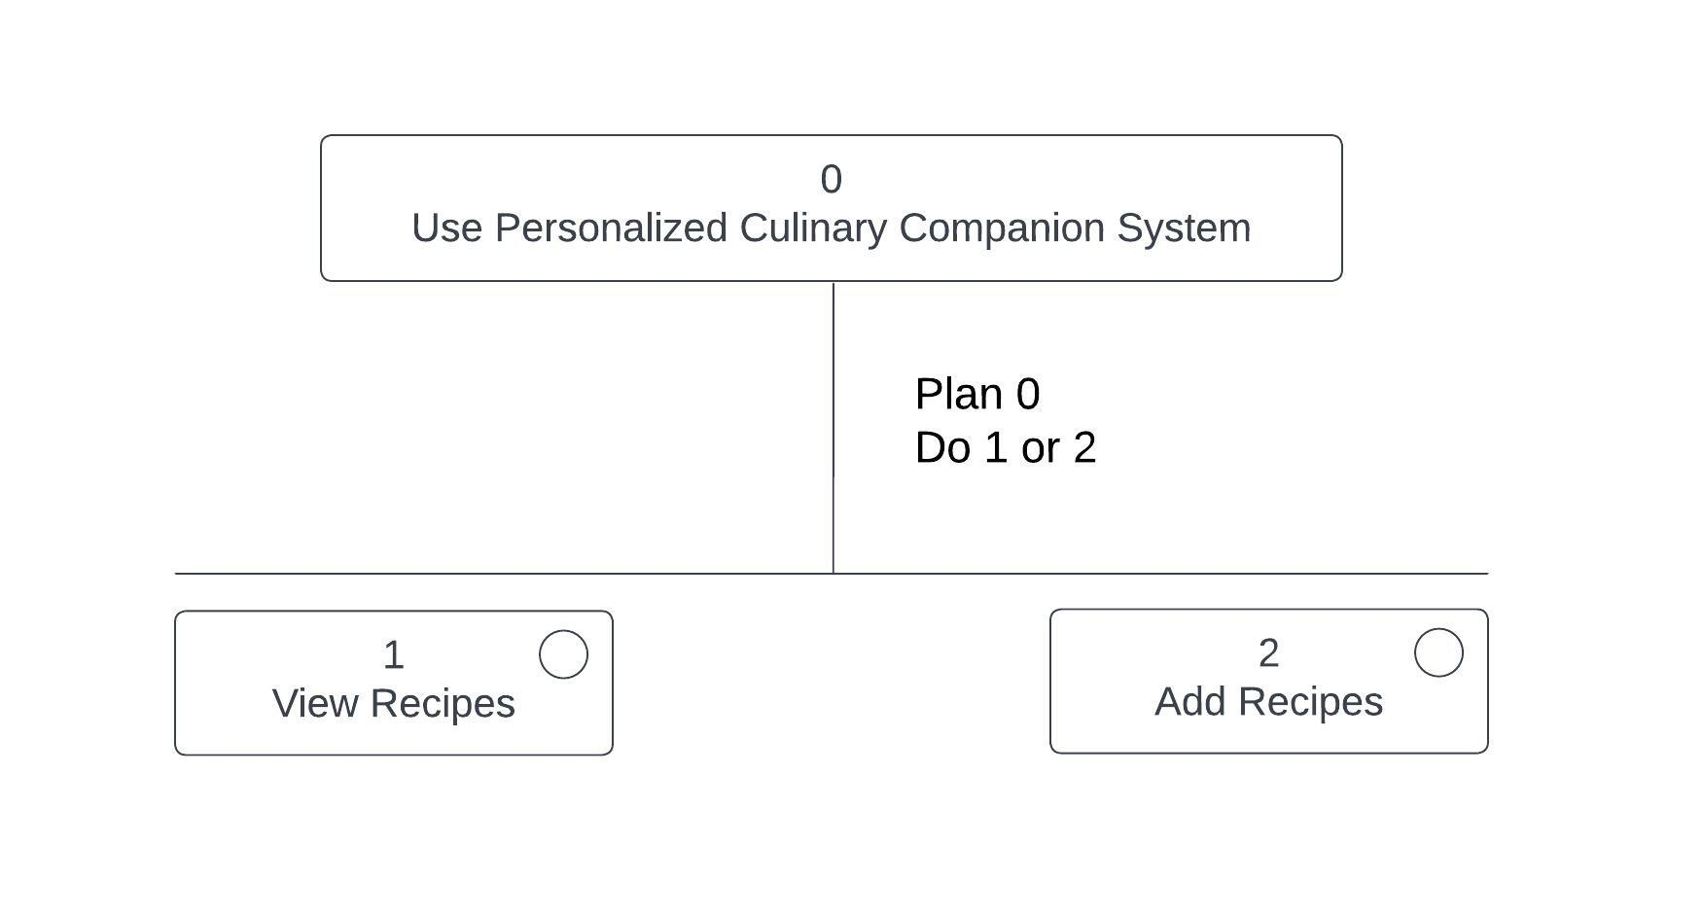

Figure 2: Root tasks of HTA

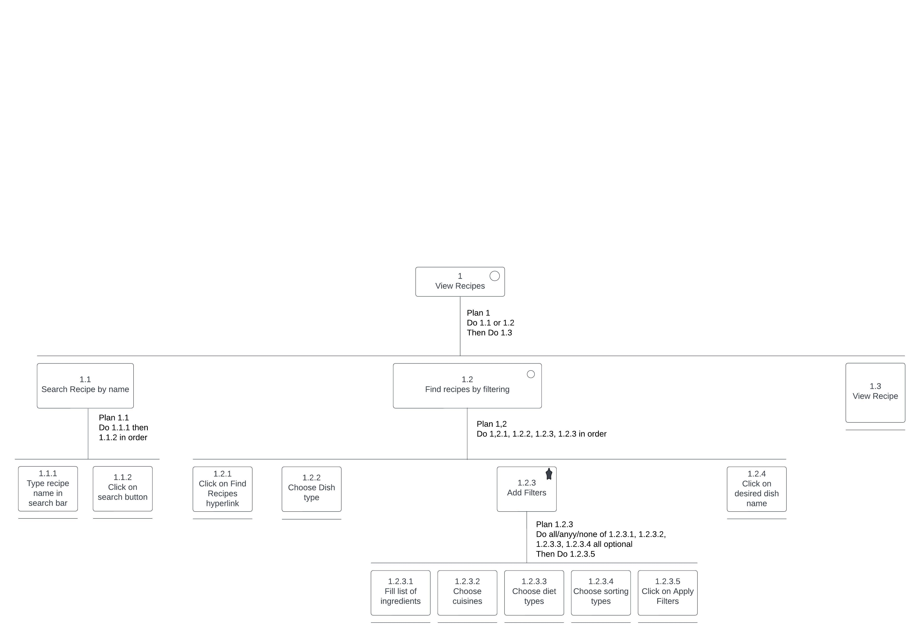

Figure 3: 1st Root Task of HTA

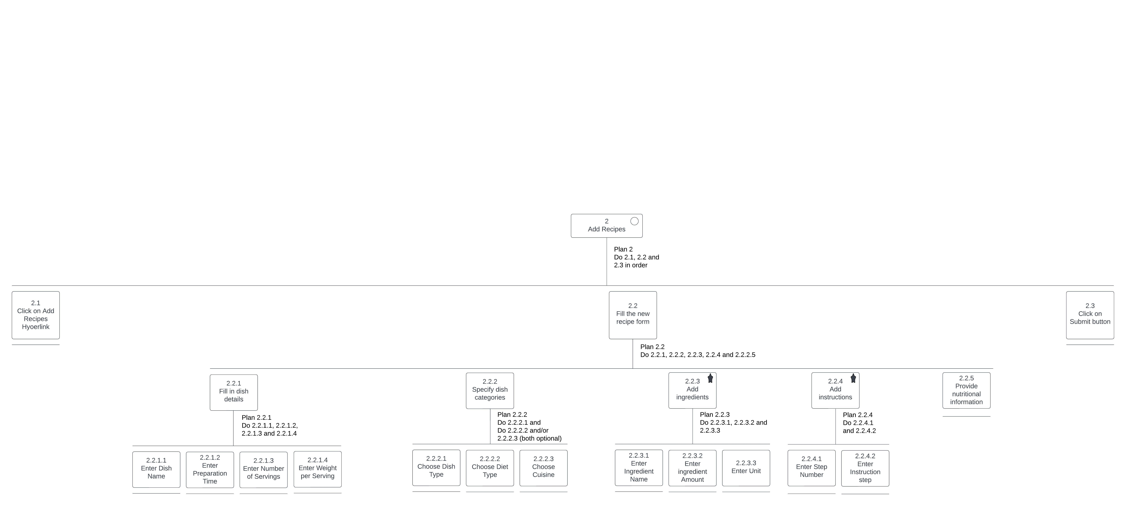

Figure 4: 2nd Root Task of HTA

**Interaction Design**

1. **Identify Goals:** In this step, the primary objectives and purposes of the system are defined.
   1. Goal 1: User-Friendly Recipe Submission
      * Objective: Design an interface that allows users to easily submit their recipes.
      * Prioritize essential information to streamline the submission process.
   2. Goal 2: Efficient Recipe Discovery
      * Objective: Create a robust search functionality for users to find recipes based on various criteria such as cuisine, dish type, and dietary preferences.
2. **Develop Personas:** Understanding the target audience by creating personas helps in tailoring the design to user needs.
   1. Persona 1: Casual Home Cook (Eva)
      * Description: Enjoys cooking as a hobby.
      * Needs: Quick and easy recipe submission, recipe discovery for inspiration.
   2. Persona 2: Health-Conscious User (Alex)
      * Description: Focuses on nutritional content.
      * Needs: Detailed nutritional information, search filters for specific dietary requirements.
3. **Create Scenarios and Storyboarding:** Scenarios and storyboards help visualize how users interact with the system.
   1. Scenario 1: Adding a Recipe (Eva)
      * Eva adds a breakfast recipe quickly using an intuitive form.
   2. Scenario 2: Finding Dinner Ideas (Alex)
      * Alex searches for low-carb dinner recipes with a specific cuisine preference.
4. **Use Case Modelling:** Use cases outline the interactions between users and the system.
   1. Use Case 1: Add New Recipe
      * Actors: Registered Users
      * Main Flow: User fills out recipe details, adds ingredients, and submits.
   2. Use Case 2: Search for Recipe
      * Actors: Registered Users
      * Main Flow: User enters search criteria, browses results, and views a detailed recipe.

**Stakeholders Identification**

Identifying stakeholders is crucial for understanding the perspectives and interests involved in the system.

1. **Users:**
   * Home Cooks (Eva): Interested in easy recipe submission and discovery.
   * Nutrition Enthusiasts (Alex): Look for detailed nutritional information and specific dietary options.
2. **Developers:**
   * Frontend Developers: Responsible for designing the user interface and ensuring a smooth user experience.
   * Backend Developers: Handle data storage, retrieval, and system functionality.
3. **Administrators:**
   * Content Moderators: Review and manage submitted recipes.
   * System Administrators: Oversee system maintenance and ensure smooth operations.
4. **Business Owners:**
   * Stakeholders with Business Interest: Invested in the success and growth of the system.

**Storyboarding**

**Use Case Modelling**

**Personas**

Below are four personas that represent the diverse user profiles for my web platform, ensuring that it caters to a broad audience with varying cooking preferences, skill levels, and lifestyle choices.

1. **Alex Cunningham - The Busy Professional**
   1. Background: Alex is a 30-year-old marketing executive with a hectic work schedule. Lives in a bustling city and enjoys exploring new cuisines.
   2. Goals:
      1. Seeks quick and easy recipes for busy weekdays.
      2. Interested in diverse recipes to add excitement to meals.
   3. Challenges:
      1. Limited time for elaborate cooking.
      2. Needs recipes that align with a healthy lifestyle.
2. **Eva Rodriguez - The Culinary Enthusiast**
   1. Background: Eva, 28, works remotely as a graphic designer. Enjoys experimenting with flavours and trying gourmet recipes.
   2. Goals:
      1. Finds joy in the cooking process and discovering unique dishes.
      2. Interested in recipes with detailed instructions and rare ingredients.
   3. Challenges:
      1. Struggles to discover new recipes beyond mainstream platforms.
      2. Desires a platform that caters to her adventurous taste buds.
3. **Samir Patel - The Health-Conscious Fitness Freak**
   1. Background: Samir, 35, works in IT and maintains an active lifestyle. Prioritizes healthy eating and follows specific dietary plans.
   2. Goals:
      1. Seeks recipes with precise nutritional information.
      2. Interested in meal plans that align with fitness goals.
   3. Challenges:
      1. Difficulty finding recipes with accurate nutritional data.
      2. Wants a platform that caters to specific dietary needs.
4. **Olivia Johnson - The Novice Cook**
   1. Background: Olivia is a 25-year-old student who recently started cooking. Has a limited culinary skill set but eager to learn.
   2. Goals:
      1. Looks for beginner-friendly recipes with step-by-step guidance.
      2. Interested in building a repertoire of easy-to-cook meals.
   3. Challenges:
      1. Struggles with complex cooking terminology.
      2. Needs a platform that encourages and educates novice cooks.

**State Transition Network**

**Application of Guidelines/Principles**

**Schneideman's Eight Golden Rules**

1. **Strive for Consistency:** The system maintains consistency in design, terminology, and interaction patterns.
2. **Enable Frequent Users to Use Shortcuts:** There are no shortcuts as such but advanced search options cater to users familiar with the system.
3. **Offer Informative Feedback**: The system provides timely feedback on search results and successful recipe submissions.
4. **Design Dialogs to Yield Closure:** The workflow for finding and viewing recipes follows a logical sequence, providing closure.
5. **Offer Simple Error Handling:** Error messages are clear and guide users on resolving issues.
6. **Permit Easy Reversal of Actions:** Users can navigate back and forth in the recipe details view, the applied filters will remain but the contents of the form will be lost.
7. **Support Internal Locus of Control:** Users do not have control over editing and deleting their recipes, so there is limited support for internal locus of control.
8. **Reduce Short-Term Memory Load:** Clear labels, placeholders, visual cues and use of checkboxes in both finding and adding recipes reduce cognitive load.

**Heuristic Evaluation**

A heuristic evaluation was conducted on the system to assess its usability and identify potential usability issues. This evaluation focuses on the two main functionalities: finding recipes and adding recipes.

|  |  |  |  |
| --- | --- | --- | --- |
| **Sl. No.** | **Heuristic Evaluation Criteria** | **Finding Recipes** | **Adding Recipes** |
| 1 | Visibility of System Status | The system provides clear feedback on the status, such as loading indicators during searches and successful submission messages. | Feedback is provided after adding a recipe, indicating success or any errors. |
| 2 | Match Between System and the Real World | The language used for dish types, cuisines, and diet types aligns with users' expectations, enhancing user understanding. | Terminology in the recipe creation process mirrors real-world cooking terms, improving user recognition. |
| 3 | User Control and Freedom | The filters are lost when the user navigates back, making it slightly tedious for them if they had to make changes in their previous selections. However, the user can make additional filter selections after getting the previous filters’ results as well. | The system does not allow users to edit and delete the recipes that they have added, so there’s limited control over their content. |
| 4 | Consistency and Standards | The layout and design are consistent throughout the recipe finding process. | The form elements maintain a consistent structure during recipe addition. |
| 5 | Error Prevention | The system prevents errors by handling empty or invalid searches gracefully. | Mandatory fields are clearly marked, reducing the likelihood of submission errors. |
| 6 | Recognition Rather Than Recall | The search interface displays recipes that match the entered keywords, aiding user recognition. | Users are prompted with clear labels and placeholders during recipe creation, and are provided checkboxes for category names (such as dish types, cuisines, and diet types), minimizing the need for recall. |
| 7 | Flexibility and Efficiency of Use | Advanced search options allow experienced users to quickly refine their queries. For expert users to follow, the filters applied are displayed as query parameters in the URL. | The recipe addition form is streamlined, catering to users of varying expertise. Those who only have basic knowledge of recipe ingredients and instructions are provided instructions to ignore the form sections about nutritional details. |
| 8 | Aesthetic and Minimalist Design | The search results only display the name of the dishes which can be clicked to get the complete dish and recipe details hence, only essential information is presented without unnecessary clutter. | The recipe creation form is very well-organized, avoiding unnecessary elements. |
| 9 | Error Recovery | The system effectively handles errors, but does not provide meaningful feedback and guidance on resolving issues. | In the recipe addition process, if there are errors or missing information, the system guides users on how to correct these issues before submission. |
| 10 | Help and Documentation | There are instructions for the application of each filter, but there is no overall help section or complete documentation available to users. | Users are given instructions about which boxes to necessarily fill and how, but other than that there is no overall help section or complete documentation available to users. |

**KLM Analysis**

**Task 1: Finding Recipes**

KLM Operators:

* K1: Press keys for typing the dish name. (N keystrokes)
* K2: Press keys for applying filters. (N keystrokes)
* P1: Move the mouse to click on suggested dish name.
* P2: Move the mouse to navigate through search bar.
* P3: Move the mouse to choose dish type.
* P4: Move the mouse to go to click on buttons and hyperlinks.
* H1: Move hands between the keyboard and mouse.
* M1: Time taken for decision-making while browsing dish names.
* M2: Time taken for decision-making while choosing dish type.
* M3: Time taken for decision-making during filtering.
* R1: Waiting for system response after applying filters.
* B: Press/Release mouse button.

Task Execution Steps:

1. Observe and click on the search bar (P2+B+B).
2. Type dish name (N keystrokes) (H1+K1).
3. Browse through suggested dish names (Scroll) (H1+P1).
4. Observe and click on suggested dish name (M1+B+B).
5. Click on 'Find Recipes' button (P4+B+B).
6. Browse through dish types (Scroll) (P3).
7. Observe and click on desired dish type (M2+B+B).
8. Apply F filters (F*N keystrokes) (F*H1+M3+K2).
9. Click on 'Apply Filters' (H1+P4+B+B+R1).
10. Browse through filtered results (Scroll) (P1).
11. Click on the desired dish name (M1+B+B).

**Task 2: Adding Recipes**

KLM Operators:

* K1: Press keys for filling out the recipe form. (N keystrokes)
* P1: Move the mouse to click checkboxes and buttons.
* H1: Move hands between the keyboard and mouse.
* M1: Time taken for decision-making during data entry.
* R1: Waiting for system response after submitting the recipe.
* B: Press/Release mouse button.

Task Execution Steps:

1. Click on 'Add Recipes' button (P1+B+B).
2. Enter dish name, preparation time, number of servings, weight per serving. (N keystrokes) (H1+K1).
3. Check checkboxes for dish types, cuisines, and diet types (H1+B+B).
4. Enter required ingredient names, amounts, and units (N keystrokes) (H1+M1+K1).
5. Enter step-by-step instructions (N keystrokes) (H1+M1+K1).
6. Enter nutritional details (N keystrokes) (H1+M1+K1).
7. Click 'Submit' (H1+P1+B+B).

**GOMS Analysis**

**Task 1: Finding Recipes**

Goal: Find a recipe efficiently.

Operators:

* O1: Observe the search bar.
* O2: Click on the input box.
* O3: Type dish name ('N' keystrokes).
* O4: Browse through suggested dish names.
* O5: Observe and click on desired dish name.
* O6: Click on the 'Find Recipes' button.
* O7: Observe Dish Type names and choose the desired dish type.
* O8: Browse through results.
* O9: If desired then apply filters (ingredient names, diet types, cuisines, preparation time, nutritional contents).
* O10: Click on 'Apply Filters.'
* O11: Browse through filtered results.
* O12: Click on the desired dish name.

Methods:

* M1: Use the mouse or keyboard for navigation.
* M2: Utilize dropdowns, checkboxes, and text input fields for data entry.
* M3: Navigate through the search bar using arrow keys.

Selection Rules:

* S1: Use the mouse or keyboard based on user preference.

Evaluation:

* Efficiency: GOMS analysis provides insights into potential optimizations for quick and efficient recipe finding.
* User Guidance: The analysis helps design the system to accommodate both novice and power users.

**Task 2: Adding Recipes**

Goal: Add a new recipe efficiently.

Operators:

* O1: Click on 'Add Recipes' button.
* O2: Fill out the recipe form (dish name, preparation time, servings, weight per serving).
* O3: Check dish types, cuisines, and diet types checkboxes.
* O4: Enter required ingredient names, amounts, and units.
* O5: Enter step-by-step instructions.
* O6: Enter nutritional details (if known).
* O7: Click 'Submit.'

Methods:

* M1: Utilize mouse or keyboard for navigation.
* M2: Use checkboxes, text input fields, and dropdowns for data entry.

Selection Rules:

* S1: Provide keyboard shortcuts for users who prefer quick interactions.
* S2: Maintain consistency with the system's overall design.

Evaluation:

* Efficiency: GOMS analysis highlights areas for optimizing the process of adding recipes.
* User Guidance: The analysis contributes to designing an intuitive and user-friendly recipe addition workflow.

**Communication, Collaboration & Groupware**

**Communication Features**

* + - 1. **Real-time Recipe and Ingredient Suggestions:**

The system employs a real-time suggestion mechanism that dynamically displays recipe and ingredient suggestions as users type in the search bar. This feature enhances communication by providing instant feedback and aiding users in finding recipes efficiently.

1. **Ingredient-based Filtering:**

Users have the ability to filter recipes based on specific ingredients. This feature enables users to communicate their preferences indirectly by selecting ingredients they want to include or exclude from their recipes.

1. **Dish Type and Cuisine Filters:**

The system allows users to filter recipes based on dish types and cuisines. Users can communicate their culinary preferences by choosing specific dish types or cuisines, providing a personalized recipe browsing experience.

1. **Filtering by Diet Type:**

Users can filter recipes based on diet types. This feature allows users to communicate their dietary preferences, ensuring that the system provides recipes aligning with their specific nutritional needs.

1. **Sorting Options:**

Users can sort recipes based on various criteria, such as preparation time or nutritional content. This feature enables users to communicate their priorities, whether they are looking for quick recipes or focusing on specific dietary requirements.

1. **Add New Recipe:**

The "Add Recipes" page provides a form for users to submit their recipes to the system. This feature allows users to share their unique recipes with the community, contributing to the overall content and communication within the platform.

**Collaboration Features**

1. **User-Submitted Recipes:**The system encourages collaboration by allowing users to submit their recipes. The "Add Recipes" page provides a form where users can share their culinary creations, fostering a collaborative environment where individuals contribute to the recipe database.
2. **Community-Driven Platform:**The user-submitted recipes, along with the filtering options, contribute to the creation of a community-driven platform. Users actively participate in building the recipe repository, ensuring a collaborative space where individuals share their expertise and experiences.
3. **Personalized Recipe Browsing:**Through various filters like dish types, cuisines, and ingredient-based filtering, users collaboratively shape their recipe browsing experience. The system adapts to user preferences, creating a collaborative platform where the community collectively influences the content available.

**Groupware Features**

1. **Shared Recipe Repository:**The system acts as a shared repository for recipes, serving as a groupware platform where users contribute, access, and benefit from a collective database of culinary creations. This shared repository enhances collaboration and information exchange among users.
2. **Collaborative Filtering:**The system incorporates collaborative filtering mechanisms, allowing users to filter recipes based on dish types, cuisines, and ingredients. This collaborative approach enables users to discover recipes that align with collective preferences, creating a shared experience within the community.
3. **User-Generated Content:**The addition of recipes by users results in a wealth of user-generated content. This groupware feature encourages users to actively contribute to the system, making it a collaborative platform where individuals share their expertise and culinary creations with the broader community.
4. **Dynamic Content Updates:**The real-time updates of recipe suggestions, filtering options, and user-contributed content create a dynamic and collaborative system. Users experience a shared environment where changes made by one user dynamically impact the collective experience of the entire community.
5. **Implicit Collaboration through Search:**The search functionality allows users to implicitly collaborate by exploring recipes based on various criteria. This groupware feature facilitates information sharing and collective decision-making as users navigate through the recipe database.

**Implementation**

**GitHub Link:** <https://github.com/a-leena/CulinaryMate_RecipeFindingWebApp>

**Demo Video Link:** <https://drive.google.com/drive/folders/1ubkbbHv-hqBEAJcc5j4jPdDcQ2MdAjGZ?usp=sharing>

**Validation**

**User Acceptance Testing**

User Acceptance Testing (UAT) is a crucial phase in the software development lifecycle where end users evaluate the application to ensure it meets their requirements. Open-source tools can be utilized for efficient and comprehensive User Acceptance Testing. One popular open-source tool that I will be employing to test my web platform is Selenium, implemented in Python.

**Test Scenarios**

Scenario 1: Suggestions Display

Objective: Ensure that the system correctly displays recipe suggestions while typing in the search box.

Test Steps:

1. Navigate to the home page.
2. Enter part of a dish name in the search bar.
3. Check if suggestions are displayed.
4. Check if the suggestions match the query string.

Expected Result: Suggestions are shown, and they contain the entered query.

Scenario 2: Recipe Search

Objective: Verify that the system accurately searches and displays the recipe for the entered dish name.

Test Steps:

1. Navigate to the home page.
2. Enter a dish recipe name in the search bar and click the search button.
3. Check if the correct recipe is opened.

Expected Result: The correct recipe page is displayed.

Scenario 3: Add Recipe

Objective: Confirm that the system correctly allows users to add a new recipe.

Test Steps:

1. Navigate to the home page.
2. Click on the "Add Recipes" button.
3. Fill out the add recipe form and submit the form.
4. Search for the newly added recipe.

Expected Result: The new recipe is successfully added and can be found through the search.

**Test Scripts Implementation**

Suggestions Display Test (suggestions_test.py)

The script navigates to the home page, enters a recipe name, and checks if suggestions are displayed.

import time

from webdriver_manager.chrome import ChromeDriverManager

from selenium import webdriver

from selenium.webdriver.chrome.service import Service as ChromeService

from selenium.webdriver.common.by import By

# Set up the WebDriver (Chrome in this case)

browser = webdriver.Chrome(service=ChromeService(ChromeDriverManager().install()))

browser.implicitly_wait(5)

# Navigate to the home page

browser.get('http://localhost:3000/')

# Locate the search bar, enter a recipe name

search_bar = browser.find_element(By.ID,'search_box')

query = "salad"

search_bar.send_keys(query)

# Assertions to check if suggestions are displayed

time.sleep(2)  # Wait for results to load

suggestions = browser.find_elements(By.CLASS_NAME,'suggestionItem')

# print(suggestions)

assert len(suggestions) > 0

print("Suggestions are shown")

for suggestion in suggestions: title_element = suggestion.text

# print(title_element)

assert query.lower() in title_element.lower()

print("Suggestions contain the query")

print("Tests Passed!")

# Close the browser

browser.quit()

Recipe Search Test (search_test.py)

The script navigates to the home page, enters a recipe name, clicks the search button, and verifies the correct recipe is opened.

import time

from webdriver_manager.chrome import ChromeDriverManager

from selenium import webdriver

from selenium.webdriver.chrome.service import Service as ChromeService

from selenium.webdriver.common.by import By

# Set up the WebDriver (Chrome in this case)

browser = webdriver.Chrome(service=ChromeService(ChromeDriverManager().install()))

browser.implicitly_wait(5)

# Navigate to the home page

browser.get('http://localhost:3000/')

# Locate the search bar, enter a recipe name, and click search

search_bar = browser.find_element(By.ID,'search_box')

query = "Classic French Mussels"

search_bar.send_keys(query)

search_button = browser.find_element(By.ID,'search_button')

search_button.click()

# Assertions to check if search results are displayed

time.sleep(2)  # Wait for results to load

page_heading = browser.find_element(By.CSS_SELECTOR,'.page-heading h1').text

print(page_heading.lower())

assert query.lower() in page_heading.lower()

print("Correct Recipe opened")

print("Test Passed!")

# Close the browser

browser.quit()

Add Recipe Test (add_test.py)

The script navigates to the home page, clicks on "Add Recipes," fills out the form, submits it, and searches for the newly added recipe.

import time

from webdriver_manager.chrome import ChromeDriverManager

from selenium import webdriver

from selenium.webdriver.chrome.service import Service as ChromeService

from selenium.webdriver.common.by import By

# Set up the WebDriver (Chrome in this case)

browser = webdriver.Chrome(service=ChromeService(ChromeDriverManager().install()))

browser.implicitly_wait(5)

# Navigate to the home page

browser.get('http://localhost:3000/')

# Locate the Add Recipes button and click on it

add_rec_btn = browser.find_element(By.ID, 'add_recipe_btn')

add_rec_btn.click()

new_recipe = {

    "dishName": "French Fries",

    "preparationTime":30,

    "servings":2,

    "weightPerServing":100,

    "dishType":"Starters & Appetizers",

    "ingredientName":"Potato",

    "ingredientAmount":4,

    "ingredientUnit":"whole",

    "stepNumber":1,

    "instruction":"Fry the potatoes."

}

# Locate the input boxes and enter data, then click on submit

dish_name = browser.find_element(By.ID,'dishName')

dish_name.send_keys(new_recipe['dishName'])

prepTime = browser.find_element(By.ID,'preparationTime')

prepTime.send_keys(new_recipe['preparationTime'])

servings = browser.find_element(By.ID,'servings')

servings.send_keys(new_recipe['servings'])

weightPerServing = browser.find_element(By.ID,'weightPerServing')

weightPerServing.send_keys(new_recipe['weightPerServing'])

dishTypeName = ""

if ' ' in new_recipe['dishType']:

    dishTypeName = new_recipe['dishType'].lower().split(' ')

    dishTypeName = ('-').join(dishTypeName)

else:

    dishTypeName = new_recipe['dishType'].lower()

dishType = browser.find_element(By.ID, (dishTypeName))

dishType.click()

ingredientContainer = browser.find_element(By.CSS_SELECTOR,'#ingredientContainer div')

ingredientName = ingredientContainer.find_element(By.NAME,'ingredientName')

ingredientName.send_keys(new_recipe['ingredientName'])

ingredientAmount = ingredientContainer.find_element(By.NAME,'ingredientAmount')

ingredientAmount.send_keys(new_recipe['ingredientAmount'])

ingredientUnit = ingredientContainer.find_element(By.NAME,'ingredientUnit')

ingredientUnit.send_keys(new_recipe['ingredientUnit'])

instructionContainer = browser.find_element(By.CSS_SELECTOR,'#instructionContainer div')

stepNumber = instructionContainer.find_element(By.NAME,'stepNumber')

stepNumber.send_keys(new_recipe['stepNumber'])

instruction = instructionContainer.find_element(By.NAME,'instruction')

instruction.send_keys(new_recipe['instruction'])

submit_button = browser.find_elements(By.CLASS_NAME,'submit-button')[0]

submit_button.click()

time.sleep(5)  # Wait for Recipe Addition Feedback to show

# Locate the search bar, enter a recipe name, and click search

search_bar = browser.find_element(By.ID,'search_box')

query = new_recipe['dishName']

search_bar.send_keys(query)

search_button = browser.find_element(By.ID,'search_button')

search_button.click()

# Assertions to check if search results are displayed

time.sleep(2)  # Wait for results to load

page_heading = browser.find_element(By.CSS_SELECTOR,'.page-heading h1').text

# print(page_heading.lower())

assert query.lower() in page_heading.lower()

print("New Recipe correctly added")

print("Test Passed!")

time.sleep(5)  # Wait to show Added Recipe

# Close the browser

browser.quit()

**Test Execution**

1. Each test script is executed individually.
2. The test executions are observed for any failures or unexpected behaviour.

**Test Results and Conclusion**

Suggestions Display Test: Passed

* Suggestions are shown and contain the entered query.

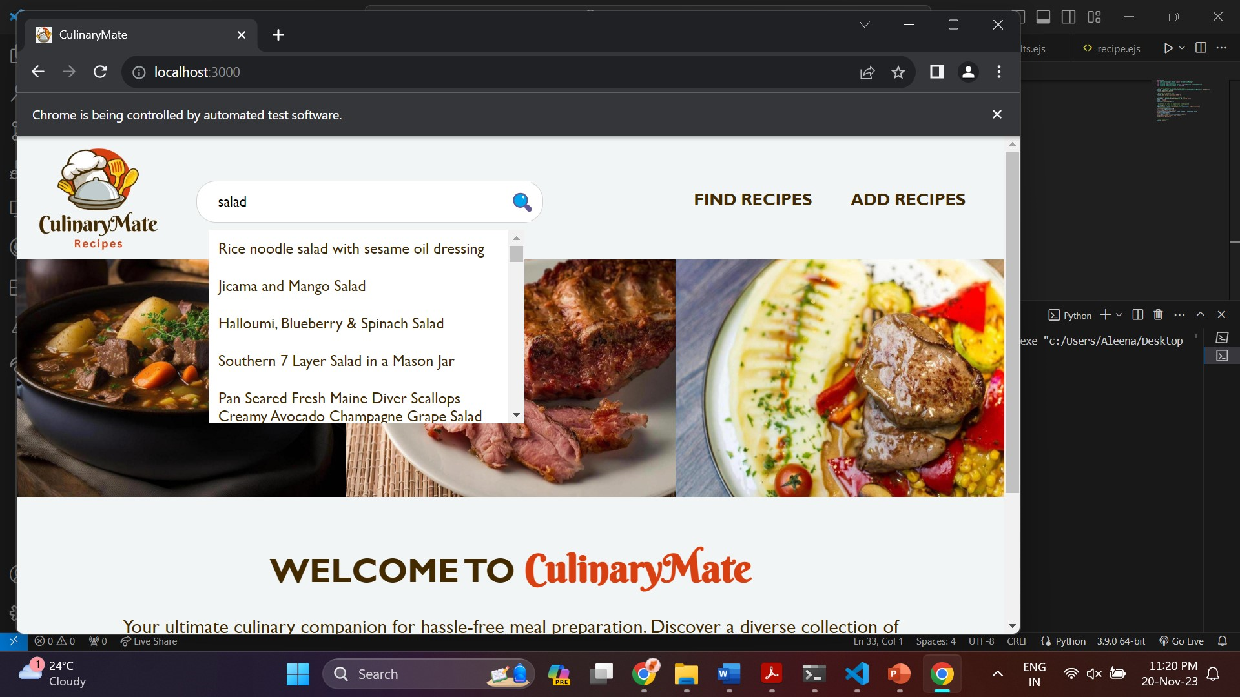

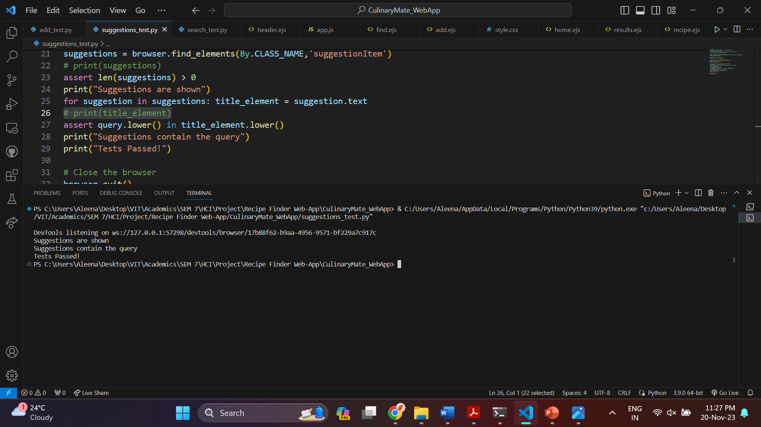

Recipe Search Test: Passed

* The correct recipe page is displayed.

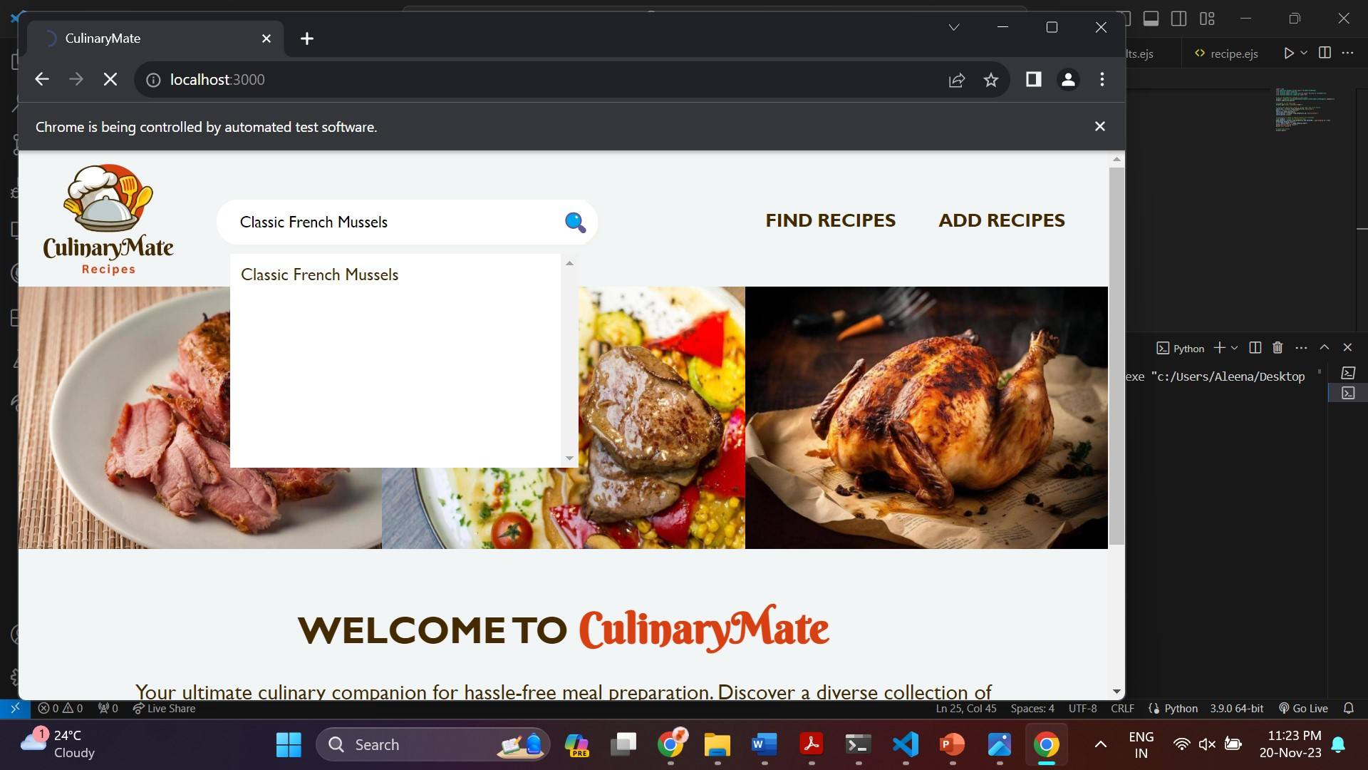

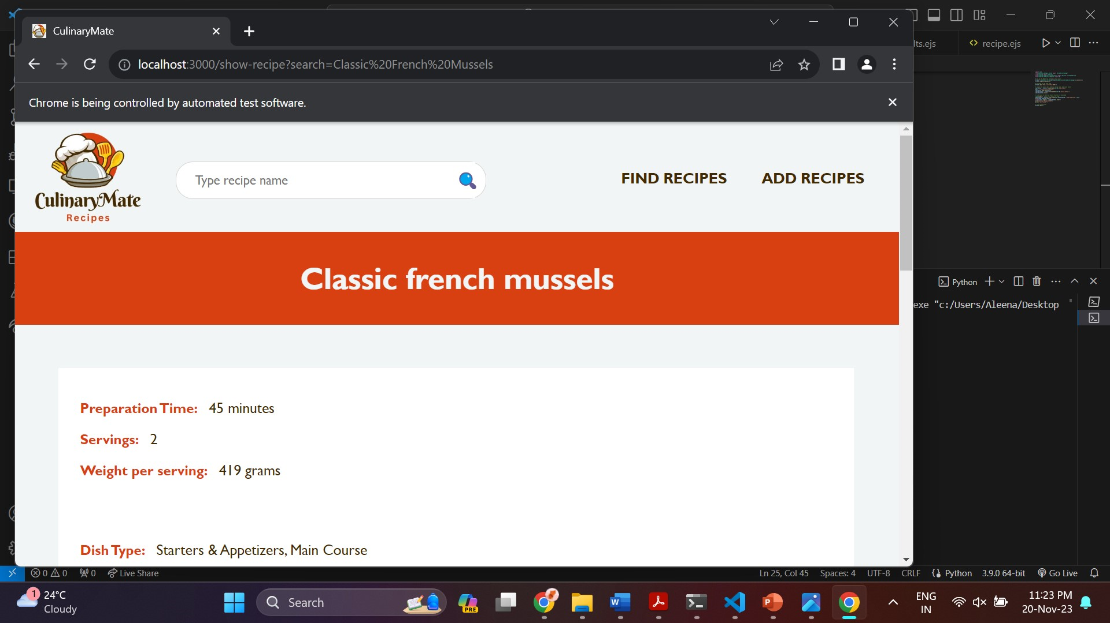

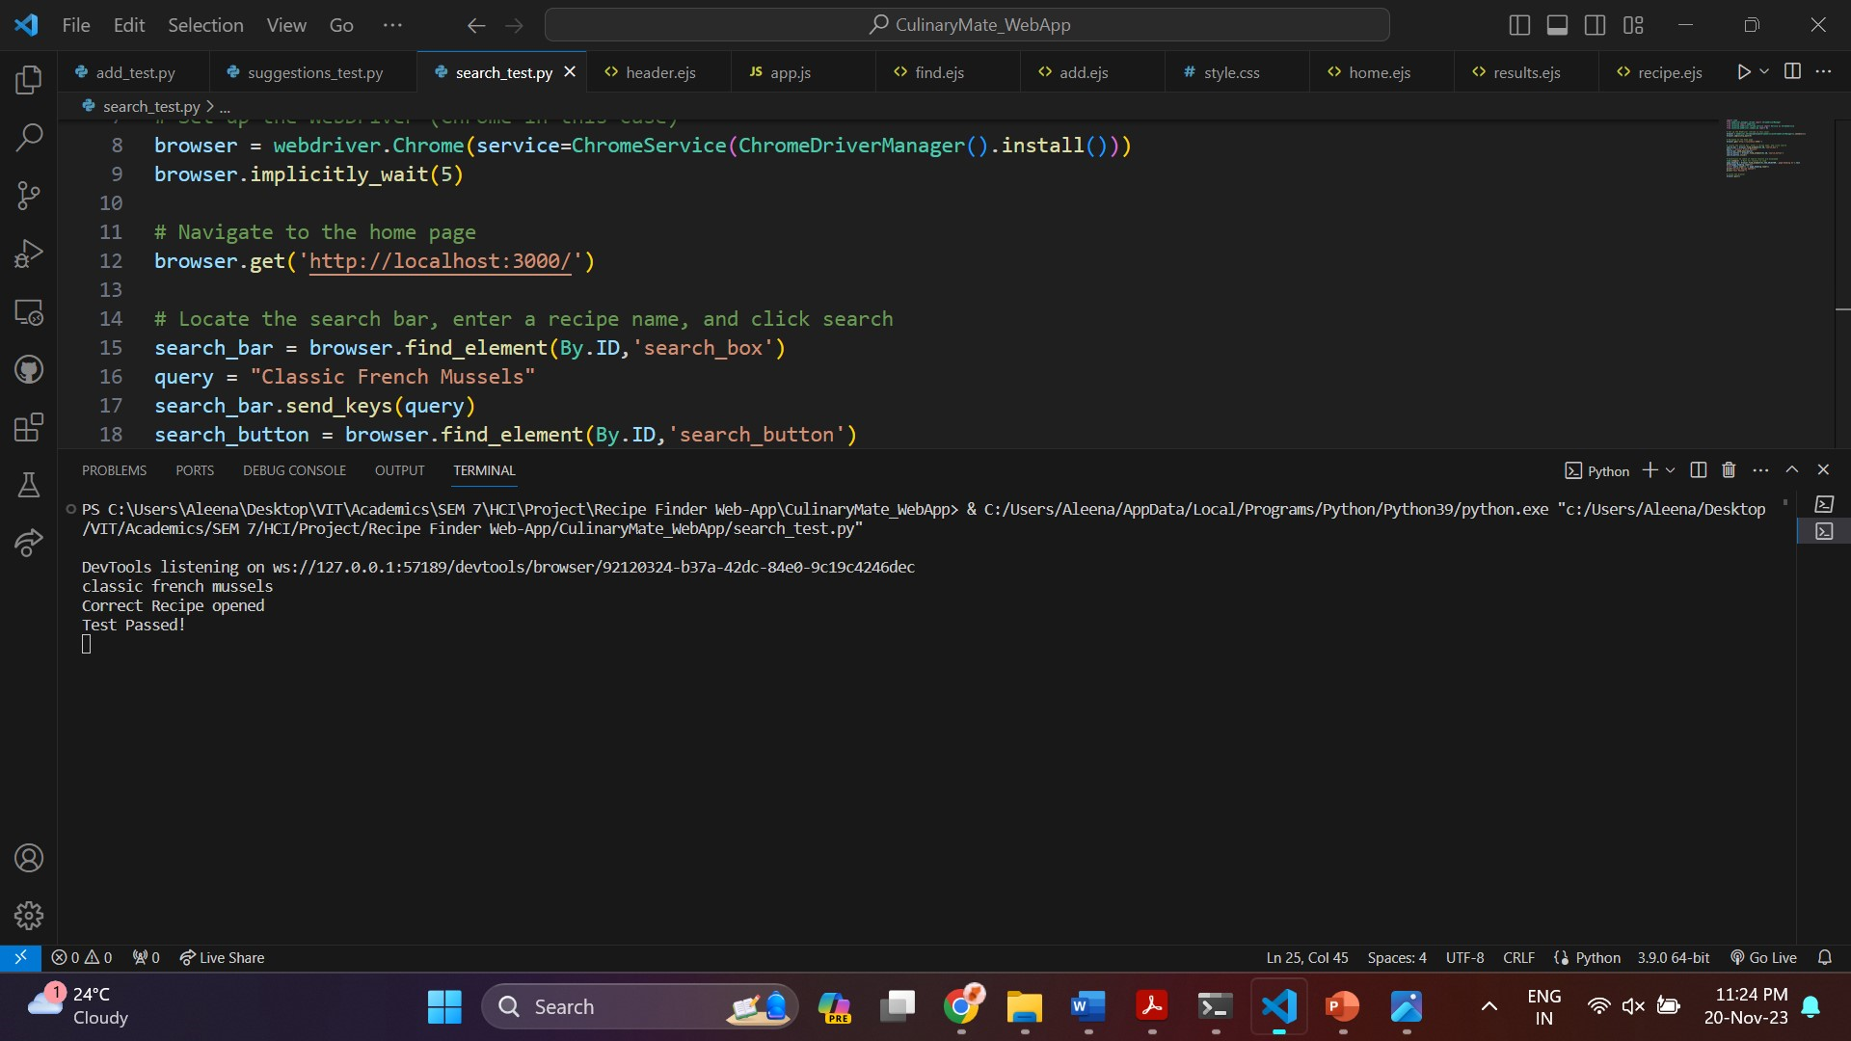

Add Recipe Test: Passed

* The new recipe is correctly added, and the search results display the added recipe.

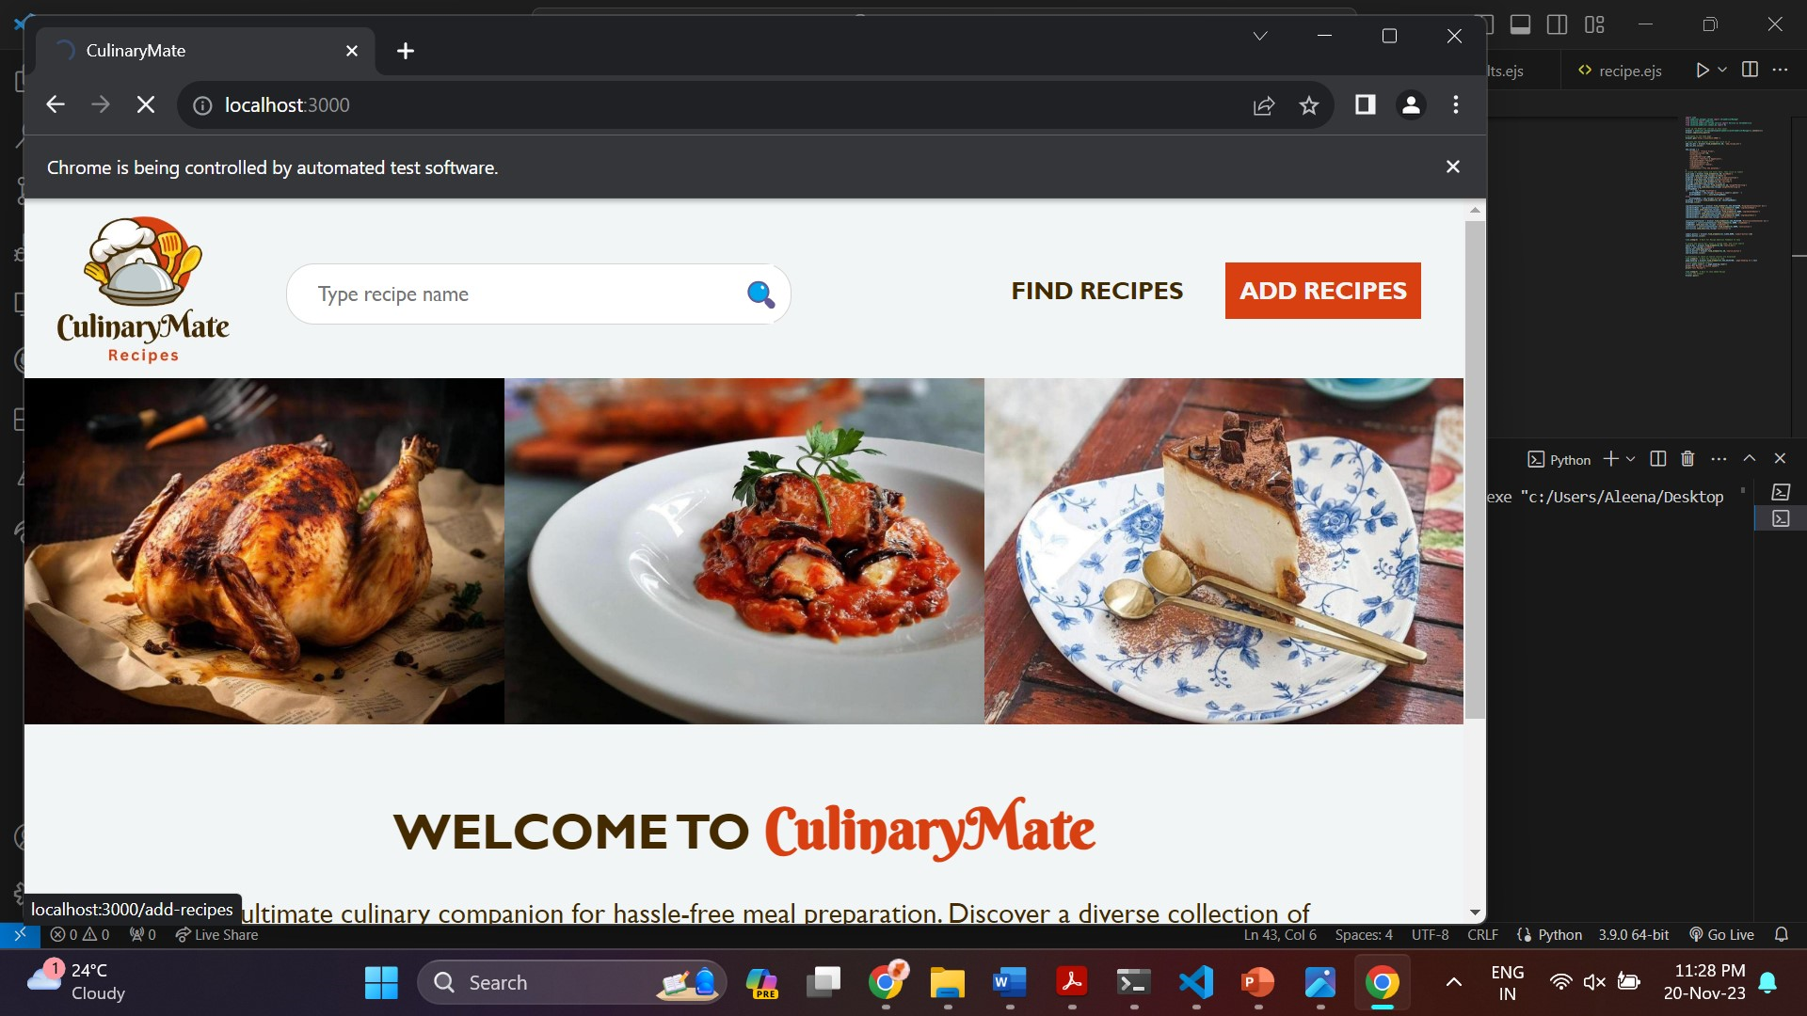

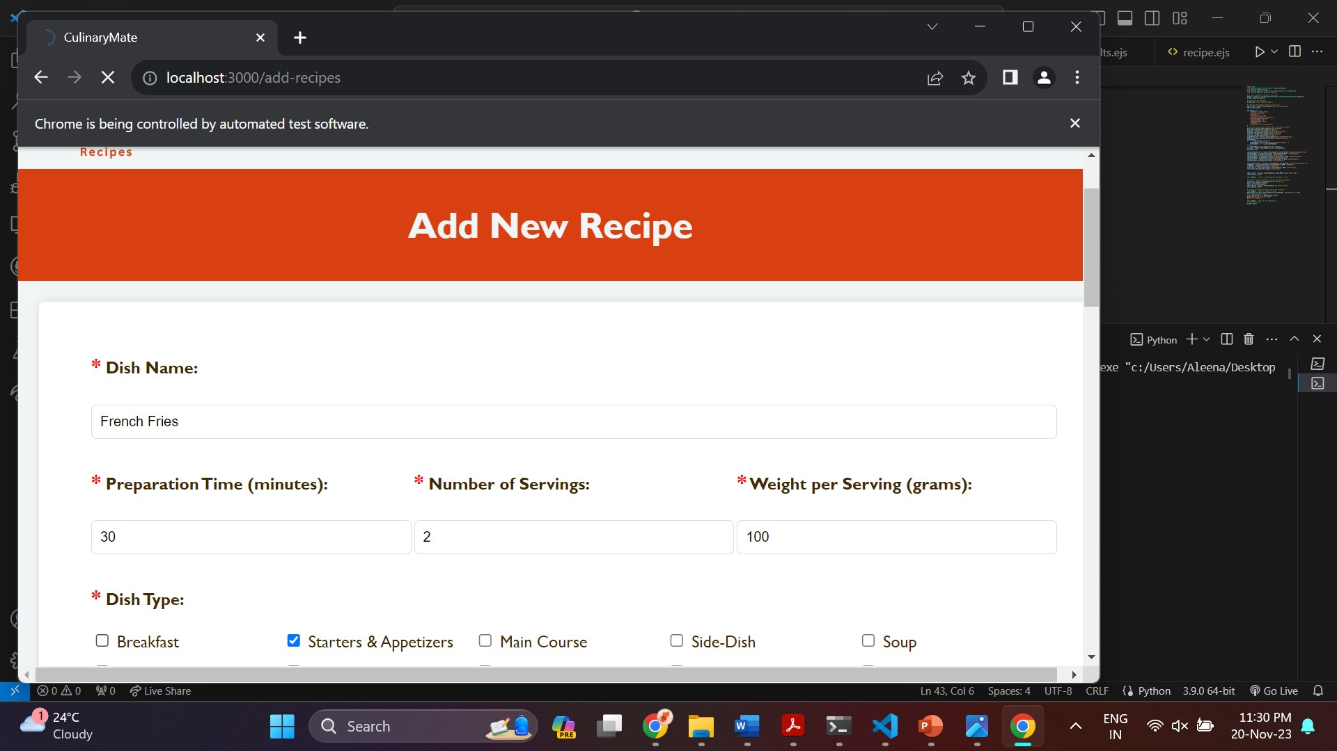

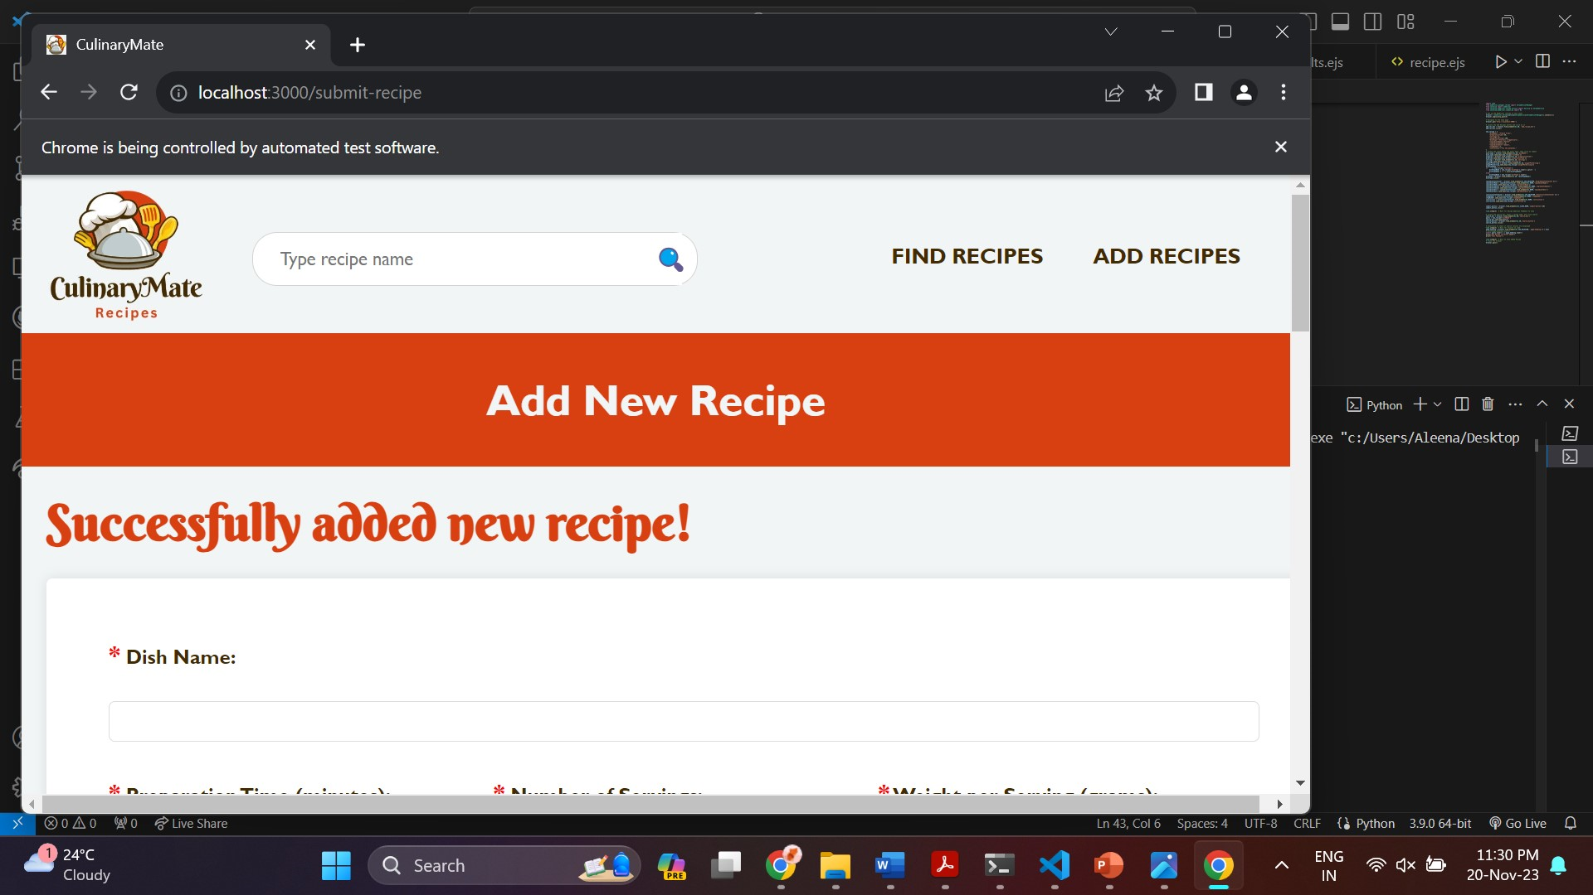

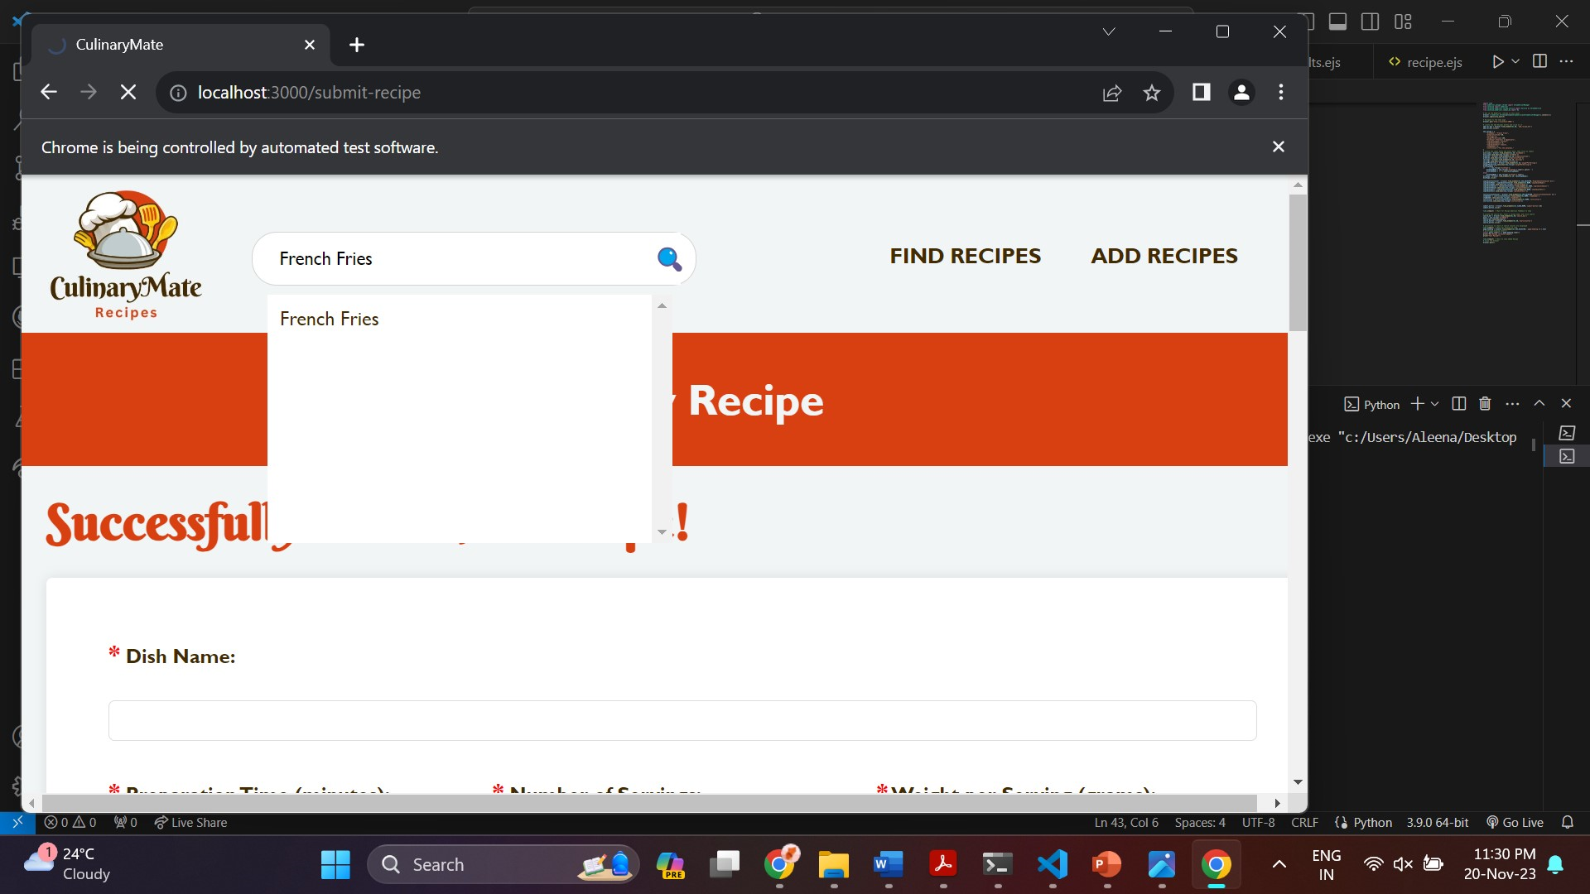

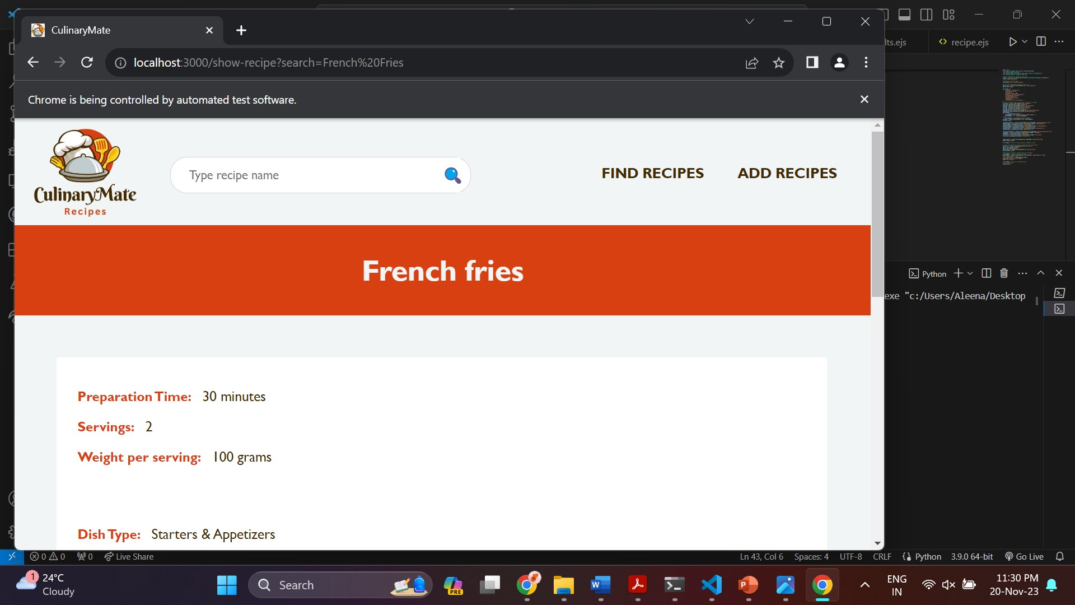

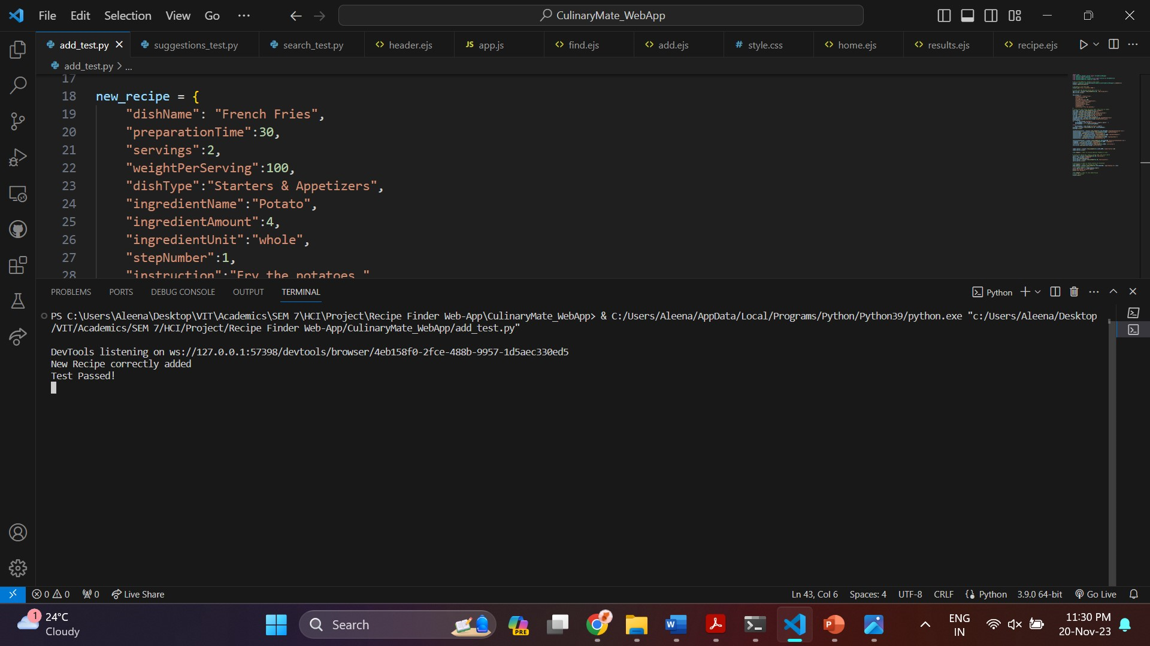

The User Acceptance Testing using Selenium confirms that my web platform functions as expected, providing a seamless user experience for searching, adding, and viewing recipes. The system meets the specified requirements and is ready for deployment.

**Results & Discussion**

**Frontend Implementation**

**Recipe Search Feature:**

The frontend recipe search feature provides a user-friendly interface for finding recipes. The interface adheres to the visibility and feedback principles, providing real-time suggestions and indicating the system's status during the search operation.

**Recipe Details Display:**

The detailed recipe view is structured for clarity and consistency. The frontend code ensures proper formatting of recipe information, including preparation time, servings, weight per serving, dish type, diet type, and cuisine. The application of Schneiderman's consistency rule is evident in the uniform presentation of these details.

**Recipe Addition Form:**

The recipe addition form, implemented using HTML and AngularJS, offers an intuitive and structured layout. The inclusion of checkbox groups for dish types, diet types, and cuisines aligns with the heuristic evaluation's suggestion for user control and freedom. Users can easily input ingredient details and step-by-step instructions, facilitated by the dynamic addition of form fields.

**Interactive Buttons and Feedback:**

Interactive buttons, such as the "Show More" button for nutritional information, enhance user control and provide informative feedback. The "Add Ingredient" and "Add Instruction" buttons in the recipe addition form demonstrate the application of Schneiderman's rule for enabling frequent users to use shortcuts, improving the efficiency of the recipe addition process.

**Backend Implementation**

**Data Processing and Storage:**

The backend code efficiently processes and stores recipe data. MongoDB serves as a reliable database, and the Node.js server handles data retrieval and updates. The system ensures consistency by employing a standardized data structure for recipes, supporting the visibility and match between system and real-world principles.

**Dietary and Nutritional Information:**

The backend code incorporates dietary and nutritional information, enabling users to make informed choices. The retrieval and display of caloric breakdown, glycemic index, glycemic load, and additional nutritional values align with the system's goal of providing comprehensive recipe details. This corresponds to Schneiderman's rule for providing informative feedback.

**Testing**

**Unit Testing:**

Frontend and backend unit tests validate the correctness of individual components. For the frontend, testing ensures proper behaviour of the recipe search and form functionalities. Backend unit tests cover data processing, filtering, and retrieval, contributing to error prevention and system reliability.

**Integration Testing:**

Integration testing verifies the seamless interaction between frontend and backend components. The testing codes provided ensure that user inputs are correctly processed, and data is accurately stored and retrieved. This contributes to the overall system consistency and reliability.

**Communication, Collaboration, and Groupware**

**User Feedback Mechanism:**

The inclusion of a feedback section in the "Add New Recipe" page enhances user communication. Users receive feedback about the success or failure of their recipe submission, contributing to the visibility of system status as per Schneiderman's rule.

**Collaborative Recipe Management:**

The collaborative nature of the Recipe Management System supports multiple users contributing to the database. MongoDB's document-oriented structure allows for scalable collaboration, meeting the requirements of groupware functionality.

**Heuristic Evaluation and Schneiderman's Golden Rules**

**Consistency and Feedback:**

The frontend and backend implementations maintain consistency in terminology, layout, and data representation. Feedback messages provide informative responses, ensuring user guidance and adherence to Schneiderman's rules.

**User Control and Efficiency:**

Interactive buttons, dynamic form fields, and keyboard shortcuts empower users, aligning with Schneiderman's rules for enabling user control and supporting efficiency.

**Error Prevention and Recognition:**

Clear error messages during form submission, input validation, and informative feedback contribute to error prevention and recognition, complying with Schneiderman's principles.

The Recipe Management System successfully integrates frontend and backend functionalities, providing a user-friendly interface for recipe search and addition. The comprehensive testing, communication features, and adherence to heuristic principles contribute to a robust and efficient system. The KLM and GOMS analyses highlight specific areas for optimization, paving the way for future enhancements in user experience and task efficiency. The collaborative nature of the system makes it a suitable tool for group-based recipe management. Overall, the implementation aligns with Human-Computer Interaction (HCI) principles, fostering a positive and effective user interaction with the Recipe Management System.

**Conclusion**

My Recipe Management web platform represents a comprehensive and user-centric solution for organizing, searching, and contributing to a diverse recipe database. Throughout the development and evaluation phases, the system has demonstrated adherence to key Human-Computer Interaction (HCI) principles, resulting in a user-friendly and efficient interface.

**Key Achievements**

**User-Centric Design:**

The user-centric design of the frontend interface prioritizes visibility, feedback, and consistency. Users can seamlessly navigate the application, search for recipes, and contribute new recipes with minimal friction.

**Comprehensive Nutritional Information:**

The inclusion of nutritional breakdowns, glycemic index, and additional nutritional values empowers users to make informed dietary choices. This aligns with the system's commitment to providing holistic recipe information.

**Collaborative Capabilities:**

The collaborative nature of the system, facilitated by MongoDB's document-oriented structure, encourages group-based recipe management. Users can collectively contribute to a diverse and expanding recipe repository.

**Areas for Improvement**

**Performance Optimization:**

While the system performs adequately under regular loads, there is room for optimization to enhance responsiveness, particularly during peak usage periods. Future iterations could benefit from performance profiling and targeted optimizations.

**Enhanced User Feedback:**

Expanding the feedback mechanisms to include more informative messages and visual cues would contribute to a more user-friendly experience. This can enhance the system's adherence to Schneiderman's Golden Rules.

**Streamlining Recipe Addition Process:**

Simplifying and streamlining the recipe addition process further, perhaps by incorporating features like auto-suggestions for ingredients and intelligent parsing of instructions, can reduce the cognitive load on users.

**Future Applicability in Real-Time Environments**

**Scalability:**

The Recipe Management System, built on a robust backend architecture using Node.js and MongoDB, is well-positioned for scalability. As the user base grows, the system can seamlessly scale to accommodate increased data and user interactions.

**Integration with IoT Devices:**

To stay ahead in the dynamic landscape of technology, considering the integration of Internet of Things (IoT) devices for smart kitchen applications could be explored. This could enable users to interact with the system using voice commands or automate certain recipe-related tasks.

**Mobile Application:**

Developing a dedicated mobile application would extend the system's reach, allowing users to access and contribute to the recipe database on-the-go. Mobile optimization and intuitive design would be crucial for an effective mobile user experience.

**Forward Outlook**

In conclusion, the Recipe Management Web Platform has successfully addressed the initial goals of creating a user-centric, collaborative, and information-rich platform. The identified areas for improvement present exciting opportunities for future development, ensuring the system remains adaptive to evolving user needs and technological advancements. As technology continues to shape the way users interact with information, this web platform is poised to evolve into a versatile and indispensable tool for culinary enthusiasts and professionals alike.